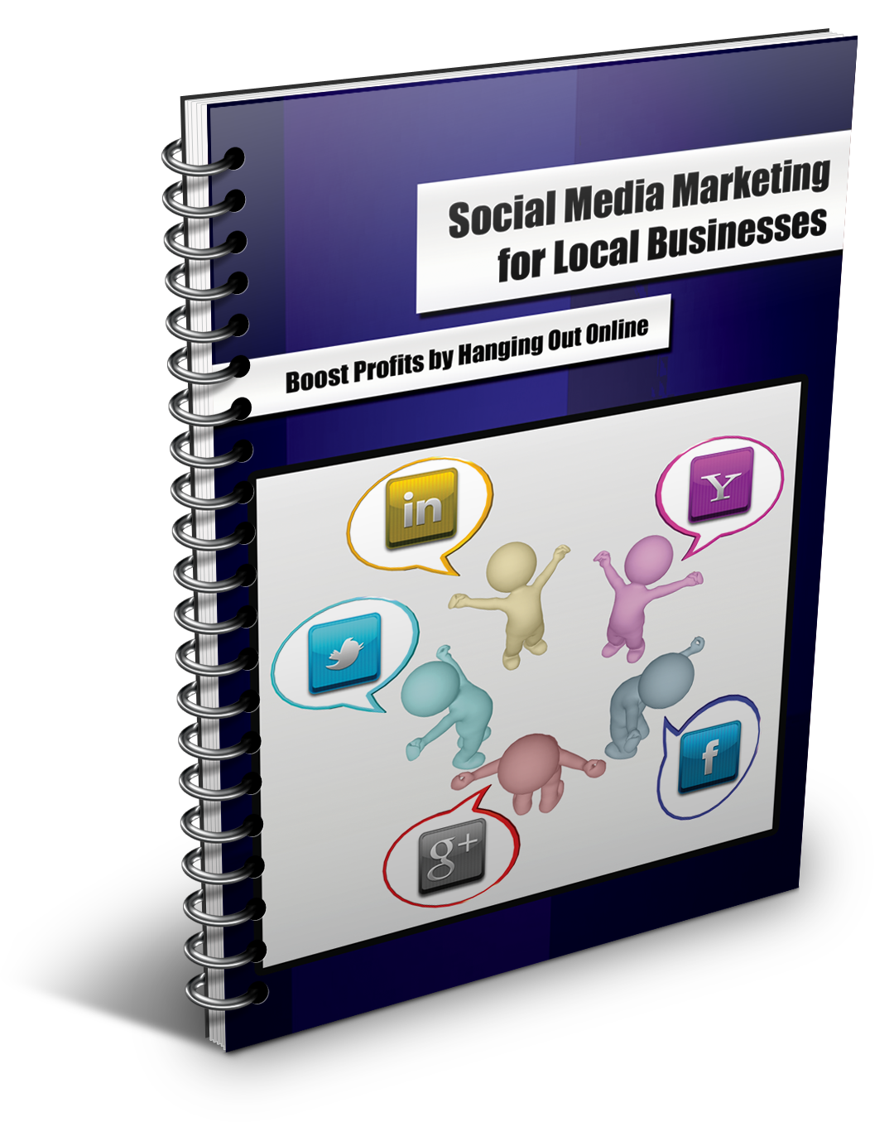

By: Your Name

Your Email Address

Your Phone Number

The Social Media Factor: What is Social Media?
“Social Media” is a red-hot buzz phrase in case you haven’t heard. Everyone is using it including women, men, and children of all ages. Most importantly, your customers are using Social media as well and they expect that your business is in the social loop too.
Social media can be described as information content that is created using new technologies with an aim to facilitate influence, communication, and interaction with the world; including friends, family, peers and customers.
In other words, social media is an advanced way that people can interact using the latest digital technology. Social media networking usually happens through mobile communications networks and the internet, which allow instant access to these platforms.
Social media does not stop at simply publishing information; the real goal is to get people involved. As a local business owner, you want to get reactions and comments from your audience on the information you publish – this is powerful for many reasons. You can look at it as “starting a conversation” on the internet as opposed to “delivering a speech” on the internet.
Social media is perceived as the glue that holds people together in an online community; not only with text, but also images, videos, and other types of online media.
Most people hear “Social Media” and immediately think of Facebook, Google Plus, Twitter, LinkedIn and other social networks of this caliber. These social platforms are the most popular, but this is not the final list by far.
There are a lot of different social media platforms online. Depending on your type of business, you should do some research to see which ones fits your type of business best.
However, using the top four social media sites would be a good start. Chances are, most of your target audience is already logging into these sites every single day.

Social Media Statistics
There are incredible opportunities for small businesses who utilize the power of social media. We will look at actual numbers just to show you how powerful it has become.
As you’ve probably noticed, social media constantly changes year after year. The good news is that people are embracing it and moving right along with it every time it changes. Even people who are 50+ in age are jumping into social media at staggering rates.
Therefore, as a small business owner, most of your customers and prospects are using it, so it’s time to reach them through this amazing marketing channel that is already made for you.
The following statistics will assist you in understanding why social media is important and how you can use it to the advantage of your business’ performance.
The Numbers
The most popular social media sites that you can take advantage of include but not limited to:
- Facebook
- Twitter
- LinkedIn
- Google Plus
2011 was a good year for social media networks; Facebook hit the 800 million users mark with 200 million fans joining in a one-year period. Twitter and LinkedIn both are enjoying over 100 million users.
There are approximately 2 billion internet users in the world and at least 50% of them use social networks.
This shows you just how much social media has taken the internet world by storm. Below are a few quick, but interesting take outs covering social media statistics for the year 2012:
2012 Statistics: Facebook & Twitter Alone
- Facebook, the most popular social media network, has approximately 800+ million users
- The average Facebook user will have a minimum of 130 friends and will like about 80 pages
- On average, 3.5 billion content pieces are shared via Facebook
- Approximately 56% of consumers have reported that they will recommend a certain brand after becoming a fan of the related page.
- Approximately 77% of consumers have admitted that they interact with businesses on Facebook before purchasing their products
- Approximately 50% of Facebook users will log on every single day
- Approximately 55% of users use their mobile phone to access the Twitter platform
- Approximately 34% of business marketers have managed to generate leads using Twitter
General Social Media Statistics
A study by Nielsen shows the following:
- Approximately 80% of Americans use social media networks
- Internet surfers will spend a considerable amount on social networks as compared to other websites
- About 40% of the people will use their mobile phone devices to access social media networks
- Social media fans are more influential and active offline
Experian released a report on the use of social media and these are some of the highlights:
- About 129 million, or 91% of American adult internet surfers, use social media networks every month
- An average Facebook user will spend at least 20 minutes every time they log into their accounts
- Approximately 20% of social media users are more likely to visit other social media sites after they exit from one
The above statistics are more than just mere numbers. They are an actual representation of just how much social media has impacted our daily lives. From these numbers, you can see that one of the best ways to reach out to your prospects and customers, without spending hundreds of thousands of dollars in advertising, is via social media.
Your business can easily communicate with your prospects through social networks and convert them into long-term customers. Your audience can get information on your new products, as well as give feedback on products and services they’ve purchased for you.
It is also a great way to build customer reviews. You should encourage your satisfied customers to go online to social media sites and give a review. Online reviews are instrumental in influencing consumer buying decisions these days. Most people go online to do a little research before they purchase anything.
So it would benefit your business to have a lot of glowing reviews online for everyone to see.
And let’s not forget about Online Reputation Management. Social media allows business owners a way to monitor and respond to what is being said about them online. With a strong social media presence, you will be given a chance to catch and correct any customer service issues that may be made public by an unhappy customer.
With the right approach, local businesses can build a healthy relationship with their customers, as well as with other like-minded companies through the use of social media. In a nutshell, it could be the key to creating more sales and profits funnels into your business.
The number of social media users is projected to increase substantially in 2012 with more than 100 million additional people joining the various networks.
As you can see, when it comes to attracting new customers and prospects, social media must be a part of the plan if you want to grow and expand your local customer reach.
We can no longer look at social media networks only as a thing for the “young generation” to express themselves. We have to look at it as a powerful marketing and advertising vehicle that can take your business to the next level without damaging your wallet.
Let’s take a closer look at some of the most popular social media platforms online today: Facebook, Twitter, Google Plus, and LinkedIn.

What is Facebook?
Before you explore this phenomenon that has stirred up the internet and the social media world, it is important to understand what Facebook really is and its relevance to the marketing industry.
Facebook is a social media network that is causing ripples on the web. This website was created with the intention of helping people connect with family and friends. Starting out as a college network site, Facebook has come a long way. In fact, it is now at the top of the list when it comes to influential social media networks.
In 2004, Mark Zuckerberg founded Facebook, which was known as “thefacebook” back then. The site was an instant hit on campus (Harvard) and slowly expanded to other colleges. With the rapid success, Zuckerberg included two other students to assist him with his new found business. Together, they churned out this nationwide networking website geared mostly towards college students.
However, today, Facebook is used by most people around the world.
Facebook gives its users the ability to create profiles so that they can share information about themselves. This includes Fan Pages, which are mostly used by businesses who want to market their companies.
One of the most powerful features of Facebook is the ability for fans and friends to comment on profiles and Fan Pages. This feature has played a huge role in turning Facebook into the ultimate place for businesses to engage with their customers and prospects.
While consumers can easily get the information they need on products and services, businesses enjoy the cheap advertising and exposure.

Why Use Facebook in Marketing?
Facebook is the number one social networking site with a massive number of daily users. The website allows businesses to create Fan Pages and use banners to set up advertisements in order to market their businesses and interact with consumers.
Facebook Trends and Statistics
The Following statistics (by Vabsite) show the numbers behind the success of Facebook in the Social media world:
- Facebook has over 800 million active profiles with 25% of these joining in a single year (2011)
- 50% of all Facebook users log into their accounts every day
- An average user has about 130 friends
- Facebook users spend 700+ billion minutes on this site every month
- Facebook has 900+ billion pieces of content that its users interact with; this includes “groups,” “events and community,” and Fan Pages
- An average Facebook user “likes” about 80 pages
- An average Facebook user will create about 90 content pieces in a month
- Ever since the launch of plugins, approximately 10,000 new sites integrate with Facebook on a daily basis
- Facebook has more than 70 translations
Facebook Mobile Usage Statistics
- There are more than 25% Facebook users who access the platform using mobile phones
- Facebook mobile users are two times more active as compared to non-mobile phone users
- More than 200 mobile phone service providers in 60 different countries are working towards promoting Facebook mobile products

Statistics Showing Why Facebook is Here to Stay
- With over 800 million active users, 1 out of every ten people on earth is using Facebook
- Statistics based on “users” and “page views” puts Facebook in the number 2 spot - second to Google, yet ahead of Yahoo and YouTube
- For every one minute on Facebook, users will share 50,000 links, tag 65,000 photos, post 80,000 wall posts, update 95,000 statuses, and post 500,000 comments to either affirm or disparage them
- American Facebook users make up to ¼ of the total users in the world

Business Marketing through Facebook
Looking at the statistics above, you can see why both large and small businesses are turning to Facebook as an effective and affordable advertising method.
Facebook users have started using this network to check out local businesses and what they have to offer. A user will browse through local restaurants, salons, flower shop, fashion shop, etc. and you want to be among the results they find.
Most of the people who use Facebook are quite active offline. This means that they are potential customers who will buy anything they think is cool once they see it on Facebook – especially from a “local” business. Therefore, if you run a local business, it is important for you to be active on Facebook now that you know the numbers involved.
Fan pages are easy to create and will not cost you a dime if you do it yourself. However, to really get the best Fan page that will fully engage your audience, it may be best to hire a professional who has extensive knowledge about Facebook marketing.
While creating a Fan page is the first step, the hard part is connecting with customers. You will need consistency and the ability to dedicate some time to build a loyal following of fans. You will need to communicate often in order to keep their attention and increase your sales.
Once you create a Facebook Fan page, you will need to let people know that you have it. One easy and quick way to do it is to put a Facebook icon on your website that is linked to your Fan Page. Another way is to include a Facebook logo in your print advertisements and any other marketing methods you use.
There are very successful companies using Facebook to increase sales and build a following. While your business will not be an instant hit with millions of fans overnight, you can eventually build a strong foundation and Facebook presence that will pay off.
If you really want to build a relationship with your customers through interaction and communication, Facebook is the way to go. Start by creating a Fan page and load it up with valuable, relevant information that your target audience will enjoy.

What is Twitter?
If you read newspapers, listen to radio stations, or watch TV, at some point you must come across the term “Follow me on Twitter”. Although these words are widely used, there are still a lot of people who don’t understand Twitter.
It is not that they are not technically savvy; it is simply because they think Twitter is complicated, but it is not. In fact, it’s one of the easiest social media sites to use.
You can’t deny that “Twitter” is a funny name that leaves a lot of people scratching their heads. However, Twitter is the 2nd largest social media networking site online with more than 100 MILLION users.
On Twitter, users can create short blog posts called “Tweets,” which allow them to tell others what they are doing.
The posts can only be up to 140 characters, which is about the same length as a text message on your mobile phone. These short posts are used to communicate, connect, and conduct conversations with your audience without saying a whole lot.
To make new contacts on Twitter, you must “follow people” or “be followed.” To connect with someone, whether it is a family member, friend or celebrity, just click on the “follow” button.
Going forward, all of their messages, or “Tweets,” will appear on your list of messages from people you follow. If a person follows you, then your Tweets will appear in their timeline.
Most of the Tweets posted are not addressed to any particular individual and usually contain information that the Tweeter wants to share with all of their followers.
You are probably starting to see how Twitter gives small business an easy and fast way to advertise new products and/or services with assurance that consumers will see them; of course, the businesses will need to have followers in order to make the messages worthwhile.

Twitter Statistics
Twitter came alive in 2006 when the first Tweet was sent on March 21st. Ever since then, Twitter has been growing rapidly both in numbers and engagement. The statistics (by Twitter blog) show the extent by which this popular social network has been growing.
- It only took three years, two months and a day for Twitter to get its billionth Tweet
- Twitter users send approximately 150 million Tweets every day; and that number is steadily increasing
- Twitter has more than 100 million users with a possible significant increase in 2012
- 55% of users use their mobile phone to access the Twitter platform
An in-depth analysis by Sysomos Inc. revealed the following information:
- 65% of all Twitter users are comprised of people aged 25 years and below
- About 92.4% of users follow 100 people or less. 97.8% follow 400 people or less. 0.94% of users follow 1000+ people.
- 93.6% users have 100 followers and below. 98% have 400 followers and below while 1.35% have more than 500 users with 0.68% having 1000+ followers
- Twitter users tend to Tweet more with the increase of followers. A Twitter user with 1000 followers will Tweet an average of 6 times while one with 1,750+ followers will Tweet an average of 10 times
- US is the most active country when it comes to Twitter activities

Tweet Your Way to Success
As mentioned earlier, Twitter is similar to text messaging, but the difference of course being that you can reach a much wider audience using Twitter.
Social networks are in the frontline of transforming businesses by giving them a way to connect with potential customers. A large number of your customers probably use Twitter; so this is a great way to keep in touch with them.
After creating a Twitter account for your local business, you will have made the first and most important step in social media marketing. The next step will be to gather followers.
While this will not be a cup of tea for everyone, the efforts you put into the campaign will pay off at the end of the day. Large corporations can get a couple of millions followers in a day, but smaller businesses can get any number between 10 and 100 in a day, which is still a great achievement.
You also need to integrate Twitter in all your advertising strategies including print advertising and internet marketing. If you have a business website, include a “Follow Me on Twitter” image link on it so that anyone who visits your website can click on it and become a “follower.”
Since Twitter is meant to allow people say what they are doing, you can easily Tweet a message about the latest developments in your business with a few short words. If more information is needed, include a link to your website or blog where they can learn more.
You can even Tweet special offers from time to time to generate sales from your Twitter following. Your main task will be to create awareness and to let people know that you have a Twitter account.
Now, your customers, prospects, and peers can follow you for fresh updates regarding your business industry.
With a growing numbers of followers, your business will start enjoying a wide audience and consequently cheap advertising. There is no better way to market your business than a method that gives you a chance to interact with your customers and potential customers directly.
Not only that, but you will also be able to get feedback on your products from your customers as well as suggestions on how to make your products or services even better.
Twitter is an important piece of the social marketing world and it can be a powerful tool for your business as well. Many of your customers probably access the Twitter platform every day, so it is definitely worth your while to implement into your marketing strategy. Create your account, build a list of followers, and turn them into loyal customers.
It is time to join the rest of the world and start connecting with consumers on Twitter. Even though Twitter usage goes beyond business usage, it is definitely an avenue that should not be ignored.

What is Google Plus?
Google Plus is the latest social networking website to hit the internet. The fact that it is from Google should have been enough evidence to prove that it would be a big thing; just like other products from Google.
Though the site is still young, all Gmail users have instant access to Google Plus, which is partly responsible for the rapid rise in users. Some experts have said that Google Plus is more engaging and compelling than Facebook due to its easy sharing and connection features.
Google Plus, most of the time abbreviated as G+ or Google+, is a new social networking and identity services site run by Google. Originally, the site was opened in June, 2011 but was soon closed due to overwhelming numbers demanding for new accounts. Google Plus was later opened in September to people of age 18 years and above without the need for invitations.
Google Plus is the integration of a number of existing services such as Google Buzz and Google Profiles, with an introduction of new services such as Circles, Sparks, Hangouts, among many others.
On a wide scope, Google Plus is viewed as Google’s idea to compete with Facebook; a rival social media network with more than 800 million users. In fact, Google Plus is Google’s fourth attempt to dominate the social media world.
But they may have cracked the code this time. There are very interesting features offered by Google Plus, which is the reason why it is causing so much buzz online.
Before you start wondering why you need Google Plus in your business, we should look at some statistics showing its progress and where numbers stand now.
The Explosive Growth of Google Plus: Statistics
- By mid-July 2011, Google Plus had grown to 10 million users, which happened over a period of two weeks of launching. After four weeks, they had reached 25 million users.
- Google Plus had reached 40 million users by October 2011 and the year ended with 90 million users (Larry Page)
- Approximately 60% of all the Google Plus users log into their accounts on a daily basis
- Approximately 80% of Google Plus users log into their accounts once a week
- Google Plus has a little over 1 million business pages
- Google Plus popularity has been on an upward trend with a quarter of its users joining in December 2011 alone (Ancestry.com)
- An analysis from ComScore, shows that the US is the biggest market for Google Plus; closely followed by India
- In just less than a day, the Google Plus iPhone application made it to the most popular application offered by the Apple app store free of cost
- The age bracket for most Google Plus users is 25 to 34 years
With these statistics, you better believe that Google Plus is so far, the fastest growing social network site today.

Let’s take a look at a few of the other popular Social media sites:
- Facebook has 800+ million users
- Twitter boasts of well over 100 million users
- LinkedIn has 100+ million users

As you can see, Google Plus is right behind them with 90+ million users even though it is still in its infancy. Don’t be surprised if you find it in the second place by the end of 2012.
According to Google officials and independent statistics, Google Plus has been deemed the fourth largest social media network in the world.

Google Plus Features
The different features available on Google Plus are extremely efficient and engaging.
Let’s take a closer look at some of the features that Google Plus has to offer:
- Circles: this is a feature that allows users to share information through organizing contact groups. The sharing can be done across the many Google services. The circles include family, acquaintances, friends, and following, which is a good way to follow celebrities or public figures.
- Hangouts: this feature enables users to chat with each other (up to 10 users at a time) using video chat applications.
- Sparks: this is a feature that allows users to identify topics they might be interested in and then share them with other users. It allows users to remain updated on topics they are interested in.
These are just a few of the many features that are offered by Google Plus. You will have to become a member of this amazing social media network to learn how the other applications work and how you can take advantage of this site to improve your business.

Relevance to Small Businesses
It is not a question of whether or not you want to join Google Plus as a business owner. The most important thing in your business is marketing and knowing where your customers are. In this internet-controlled world, you should use any means necessary to reach your customers online.
To be successful in marketing your local business, you have to move with technology and even if you only attract 10 new customers via Google Plus, the account is worth it.
In efforts to maintain a customer base and attract new prospects you should be in constant communication with them. Google Plus gives your business an opportunity to take your marketing messages where your target audience is spending their time.
Google Plus is as effective as any of the three major social networks and can assist your small business a great deal. If you are looking to boost your business, you should conduct research to see how many potential customers you can reach through the use of Google Plus.
This could be the next big thing in Internet marketing, so don’t get left behind.

What is LinkedIn?
When most people talk about “Social Media,” they only concentrate on Facebook and Twitter. While these are the biggest social media sites, they are certainly not the only ones doing well. LinkedIn has managed to gather approximately 100 million users and is now one of the most influential social media networks on the internet.
You have probably received an invitation to LinkedIn from a friend or peer over the past few years. Did you accept? Do you even have a LinkedIn account? If not, you are missing out on a huge networking opportunity.
Many local businesses ignore this platform simply because they don’t understand how powerful it can be for exposing and growing their businesses.
LinkedIn is the most popular social networking sites when it comes to online “business networking”. It is a platform that allows business people and professionals all over the world, regardless of their industry, to connect with other professionals.
It is a great environment where individuals connect with multiple like-minded individuals who share interests in the business and professional world. LinkedIn users can even display updates on recent projects and give other users an opportunity to see what they are working on.
The aim of the connection is to share information, market products and services, find jobs, form business-to-business relationships, and much more. LinkedIn is basically free to use, but has premium paid packages that contain more functionality.
LinkedIn works similar to other social networks. You join by simply signing up and then creating a profile which should include any information about yourself that you want to share; such as, employment history, education, achievements, and more. You can then easily link your account to other social network sites, websites and blogs to increase exposure to your profile.

LinkedIn Statistics
Statistics aggregated by Amodiovalerio verde show the following numbers:
- LinkedIn has approximately 147 million members.
- The standard Linked in member is aged 25 to 54 years old.
- 66% of LinkedIn members are located in Europe and N. America.
- LinkedIn’s members have grown by 45% worldwide compared to January 2011.
- Over 40% of members of LinkedIn are employees in companies that employ 10,000+ employees.
Quantcast has the following statistics:
- LinkedIn has more than doubled their monthly visits to 94.3 million in Sept 2011 from 45.8 million in 2010.
- Quantcast breaks down LinkedIn visitors to addicts, regulars and passersby. Addicts account for 1% of members and will use LinkedIn on a daily basis for interaction. Regulars account for 33% of the users and will use the site for interaction more than once but less than 30 times in a period of one month. Passersby accounts for the other 66% and they will visit the site or interact with media only once in a period of one month.
- Approximately 26% of LinkedIn members are between the ages of 18 and 34, while members between the ages of 35 and 50 account for 70% of total members.
- Approximately 75% of members are college graduates and roughly 39% of LinkedIn members earn more than $100,000 every year.

What this Means for Your Business
From these numbers, you can draw a simple conclusion; LinkedIn is an important part of social media that can boost your business if approached properly. LinkedIn is here to stay so you can confidently direct your efforts to improving your business through this powerful social media tool.
Imagine being able to keep track of industry developments and related news just by logging into your LinkedIn account. Connecting with other businesses in your industry can prove to be a very profitable thing. It provides great opportunities in terms of business ventures that would have been missed without it.
For instance, if you run a Fashion Design business, you can connect with groups in this line of business. Doing so will allow you to gain access to a wealth of information as well as connect with other related businesses in that field, such as marketers and distributors who can help expand your company even further.
If you are searching for highly qualified employees, then LinkedIn is one way to find them. LinkedIn is a platform that has a large number of freelancers and job-seekers who possess skills that can take your business to new horizons.
The success of LinkedIn is fueled by the profile you create and how much you reach out to other people.
In other words, social media sites such as Facebook and Twitter are more geared towards “social networking,” while LinkedIn is more geared towards “business connections.”
With multiple opportunities in hand, small business owners have the power to better their businesses using LinkedIn. It is a great marketing tool that is worth learning if you are serious about growing your business.
With so many different social networks on the internet, it may be hard for you to decide which ones you should use. While LinkedIn may not seem important, it could be the missing link you need to take your business to the next level.
By now, you should have a much clearer understanding of why Social Media Marketing is so important for the success of your local business. If most of your customers and prospects are spending a lot of time there, there is no reason your business should not have a presence there. It’s almost like leaving money on the table.
If you would like the help of a professional Social Media specialist to get your Social Media profiles setup and working, contact me at __________ for a free consultation.
I look forward to your call.
(Your Name)
(Your Phone Number)
(Your Website)

